Aetna Agent Appointment Process

Everything is filled out through an online submission.

- Go to www.Aetna.com

- Click Explore Aetna sites in the upper right hand Corner

- Click for Agents/Brokers from the dropdown

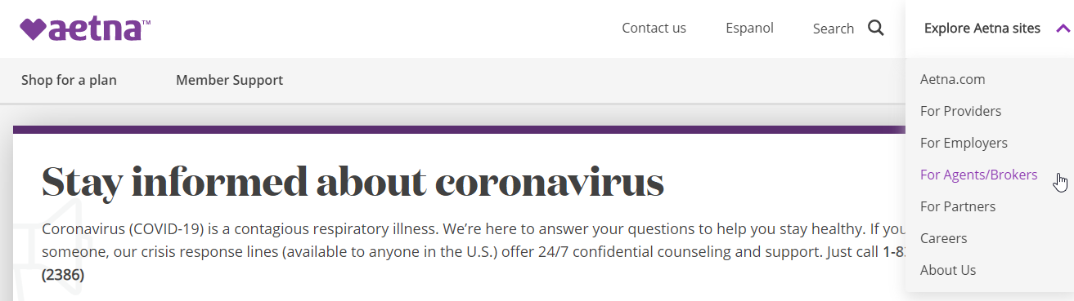

- Login or register for Producer World

- Click on License and Appointment information

- You should be able to apply online and submit all necessary documentation

** Below is a copy of the Aetna Agent agreement

